OPPOSITION Nо B 3 241 877

The Polo/Lauren Company L.P., 650 Madison Avenue, 10022 New York, United States (opponent), represented by Cabinet Cande-Blanchard-Ducamp (Aarpi Plasseraud IP Avocats), Rue de Richelieu, 104, 75002 Paris, France (professional representative)

a g a i n s t

Huixiao Yu, Group 3, Mache Village, Futian Street, 322001 Yiwu City, Zhejiang Province, China (applicant), represented by Krzysztof Breguła, Zjednoczenia 95, 43-250 Pawłowice, Poland (professional representative).

On 03/06/2026, the Opposition Division takes the following

DECISION:

1. Opposition No B 3 241 877 is upheld for all the contested goods.

2. European Union trade mark application No 19 180 363 is rejected in its entirety.

3. The applicant bears the costs, fixed at EUR 620.

REASONS

On 18/06/2025, the opponent filed an opposition against all the goods of European Union trade mark application No 19 180 363  (figurative mark). The opposition is based on European Union trade mark registration No 4 049 201, 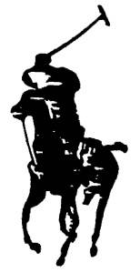 (figurative mark). The opponent invoked Article 8(1)(b) EUTMR and Article 8(5) EUTMR.

REPUTATION – ARTICLE 8(5) EUTMR

In relation to Article 8(5) EUTMR, the opponent invoked earlier European Union trade mark registration No 4 049 201.

According to Article 8(5) EUTMR, upon opposition by the proprietor of a registered earlier trade mark within the meaning of Article 8(2) EUTMR, the contested trade mark will not be registered where it is identical with, or similar to, an earlier trade mark, irrespective of whether the goods or services for which it is applied are identical with, similar to or not similar to those for which the earlier trade mark is registered, where, in the case of an earlier European Union trade mark, the trade mark has a reputation in the Union or, in the case of an earlier national trade mark, the trade mark has a reputation in the Member State concerned and where the use without due cause of the contested trade mark would take unfair advantage of, or be detrimental to, the distinctive character or the repute of the earlier trade mark.

Therefore, the grounds for refusal of Article 8(5) EUTMR are only applicable when the following conditions are met.

• The signs must be either identical or similar.

• The opponent’s trade mark must have a reputation. The reputation must also be prior to the filing of the contested trade mark; it must exist in the territory concerned and for the goods and/or services on which the opposition is based.

• Risk of injury: use of the contested trade mark would take unfair advantage of, or be detrimental to, the distinctive character or repute of the earlier trade mark.

The abovementioned requirements are cumulative and, therefore, the absence of any one of them will lead to the rejection of the opposition under Article 8(5) EUTMR (16/12/2010, T-357/08, BOTOCYL / BOTOX, EU:T:2010:529, § 41; 16/12/2010, T-345/08, BOTOLIST / BOTOX, EU:T:2010:529, § 41). However, the fulfilment of all the abovementioned conditions may not be sufficient. The opposition may still fail if the applicant establishes due cause for the use of the contested trade mark.

In the present case, the applicant did not claim to have due cause for using the contested mark. Therefore, in the absence of any indications to the contrary, it must be assumed that no due cause exists.

a) Reputation of the earlier trade mark

Reputation implies a knowledge threshold that is reached only when the earlier mark is known by a significant part of the relevant public for the goods or services it covers. The relevant public is, depending on the goods or services marketed, either the public at large or a more specialised public.

In the present case, the contested trade mark was filed on 30/04/2025. Therefore, the opponent was required to prove that the trade mark on which the opposition is based had acquired a reputation prior to that date. In principle, it is sufficient that the opponent show that its mark already had a reputation on that date. While it follows from the wording of Article 8(5) EUTMR that the conditions for its application also need to be present at the time of taking the decision, and therefore the reputation of the earlier mark must subsist until the decision on the opposition is taken, any subsequent loss of reputation is for the applicant to claim and prove.

The evidence must also show that the reputation was acquired for the goods for which the opponent has claimed reputation, namely

Class 25: Clothing, footwear, headgear.

The opposition is directed against the following goods:

Class 25: Hats; mitres [hats]; gloves [clothing]; footwear; visors being headwear; headwear; clothing; jerseys [clothing]; berets; top hats; hat frames [skeletons]; scarfs; knickers; headscarfs; socks.

In order to determine the mark’s level of reputation, all the relevant facts of the case must be taken into consideration, including, in particular, the market share held by the trade mark, the intensity, geographical extent and duration of its use, and the size of the investment made by the undertaking in promoting it.

On 23/12/2025, the opponent submitted evidence to support this claim. As the opponent requested that certain commercial data contained in the evidence be kept confidential vis-à-vis third parties, the Opposition Division will describe the evidence only in the most general terms without divulging any such data. The evidence consists of the following documents.

• Evidence 3: press clippings commenting on or promoting the goods (mainly clothing) under the polo player sign in Europe (Germany, Spain, France, Italy, Portugal), dated 2019 to 2024.

• Evidence 4: press clippings in English and French (e.g. from The Guardian, Time, Elle, Grazia, Les Echos and Vogue), dated 2018, referring, to the history and 50th anniversary of ‘Ralph Lauren’.

• Evidence 5: brand rankings (dated 2000-2023) showing the opponent’s marks ‘RALPH LAUREN’, or 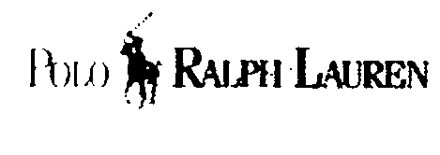 as some of the world’s most valuable and influential brands. In 2015, ‘Ralph Lauren’ was ranked 91st by the ‘Interbrand Best Global Brands’ with a brand value of USD 4 629 million, and in 2016 it was ranked 96th with a brand value of USD 4 092 million. The Reputation Institute ranked ‘RALPH LAUREN’ 50th in its global brand ranking for 2018 and 34th for 2019.

• Evidence 6: advertising campaigns in Europe (Germany, France, Italy, Spain) relating to clothing, footwear and headgear articles, dated between 2019 and 2024. For example, advertising in 2022 in France 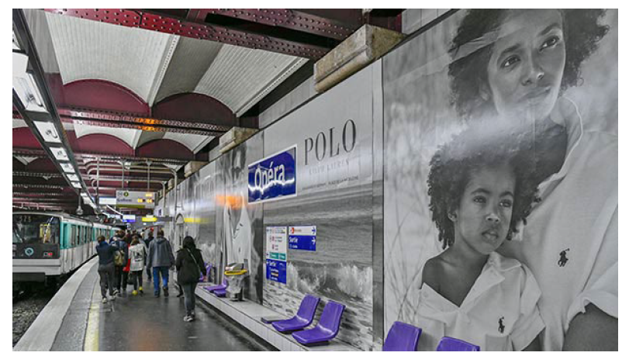 (Opéra subway, Paris) and 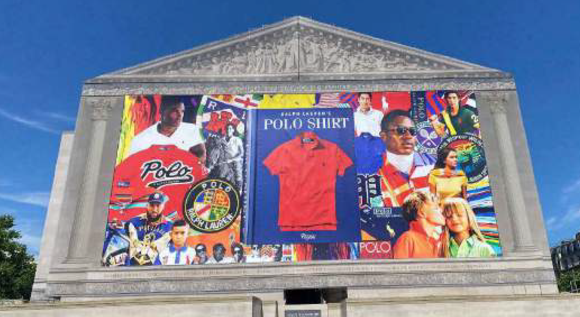 (Place de la Madeleine, Paris).

• Evidence 7-10: press articles and social media extracts (2019-2023), relating to the opponent’s sponsorship of the Wimbledon tennis tournament 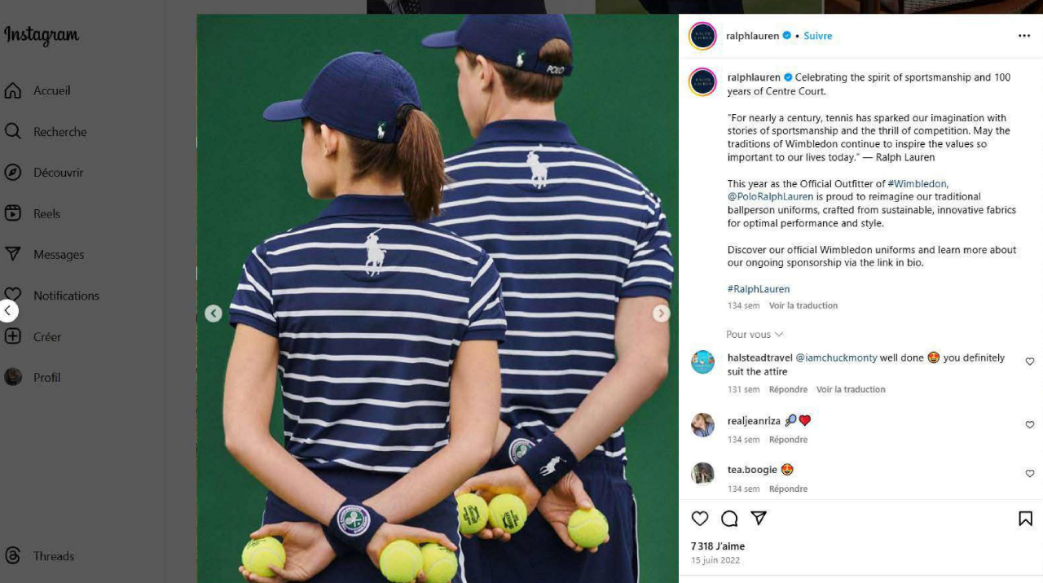, the US Open tennis tournament, the Olympic Games –where the opponent supplied the official uniforms for the US team – and the Australian Open tennis tournament 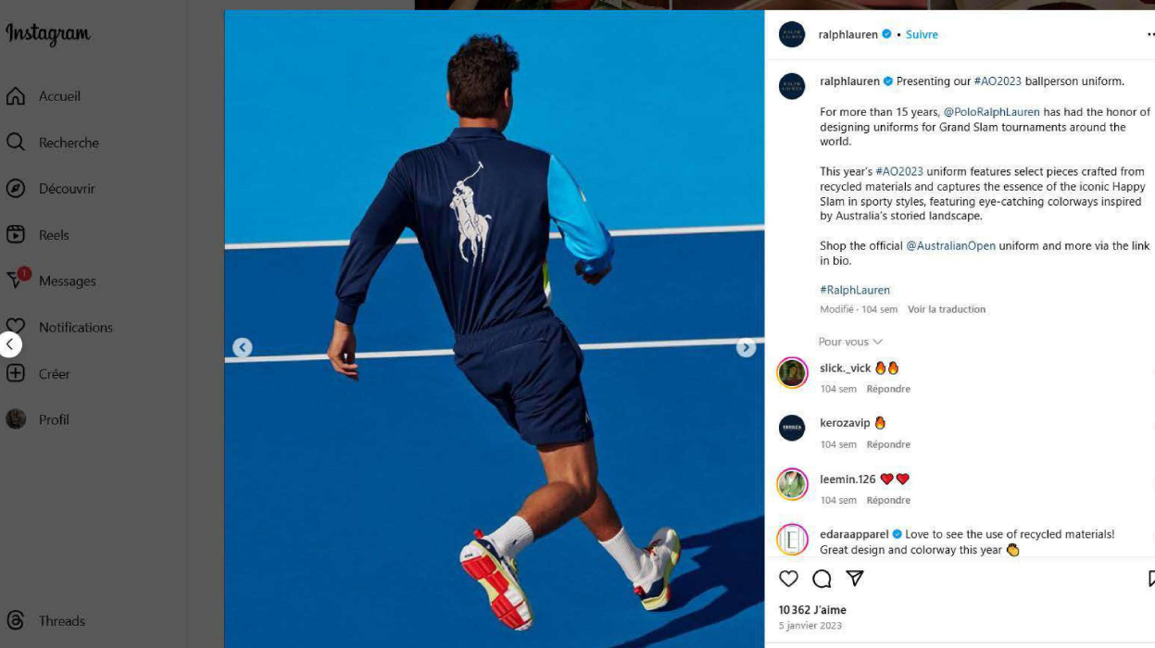.

• Evidence 11: information (dated 2019-2023) regarding use of the earlier mark on social media (Instagram), such as 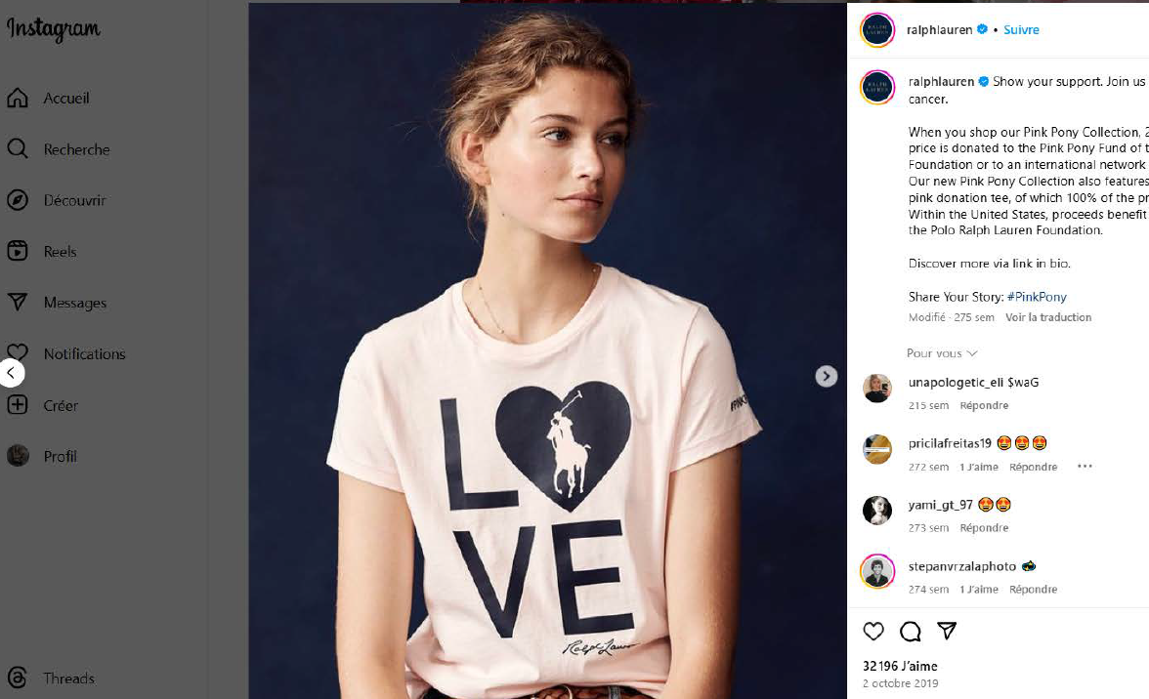 or 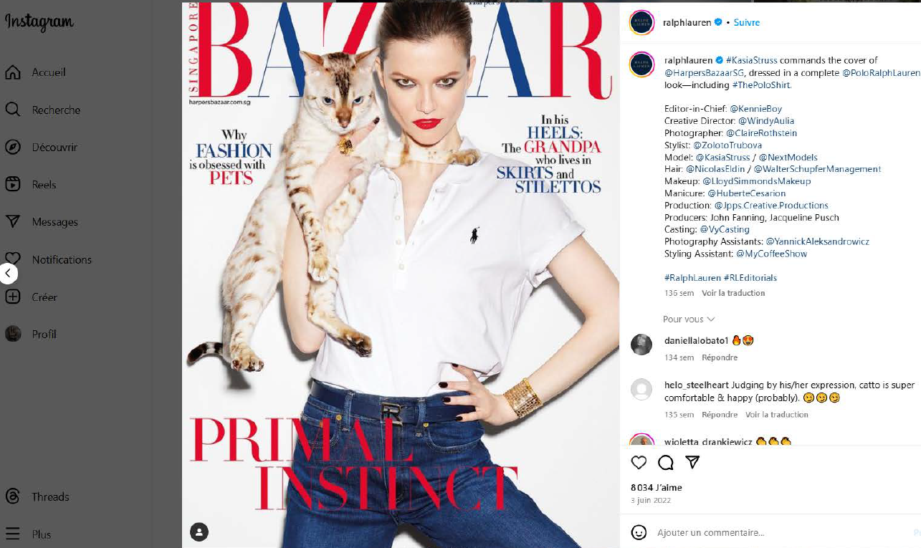 , showing various posts containing images of clothing, footwear and headwear displaying the earlier mark, with many likes.

• Evidence 12-14: media plan for the ‘Pink Pony’ advertising campaign using the logo (2013-2015), referring to publication in, inter alia, Le Figaro, Le Point, Le Monde, Marie Claire and Grazia, and evidence concerning the ‘Pink Pony’ campaign showing the earlier mark on clothing items.

• Evidence 15-22: catalogues and advertisement for footwear, dated 2019-2023, for example 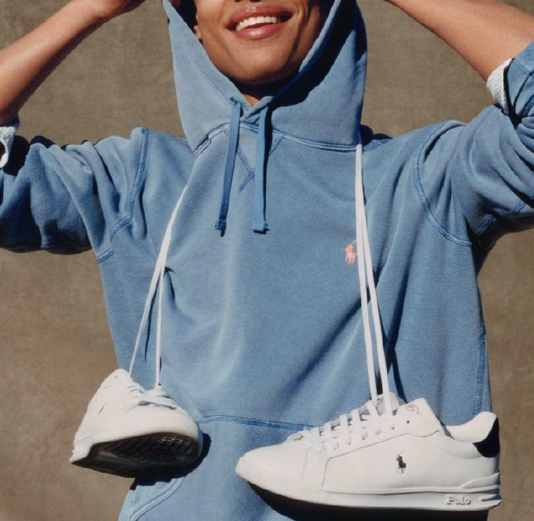 .

• Evidence 23-24: affidavits (dated 06/07/2022 and 29/07/2022) from a member of the Board of Directors of Ralph Lauren Europe, relating to sales figures for ‘POLO’ branded goods in France (2005-2022 and 2017-2022).

• Evidence 25: a table summarising sales in Europe of Ralph Lauren goods featuring the Polo Player logo and the ‘POLO’ trade marks (2018-2023).

• Evidence 26: sales figures for Polo Player branded footwear in Europe between 2018 and 2022.

• Evidence 27: list of the opponent’s stores in Europe (e.g. 22 in France).

• Evidence 28: various Opposition Division and Boards of Appeal decisions, as well as decisions from the French Patent and Trade Mark Office (INPI) and French (Paris) Court of Appeal, confirming the reputed character of the earlier mark.

On 13/05/2026, after expiry of the time limit, the opponent submitted additional evidence. In the present case, the issue of whether or not the Office may exercise the discretion conferred on it by Article 95(2) EUTMR to take into account the additional evidence can however remain open, as the evidence submitted within the time limit is sufficient to prove the reputation of the earlier trade mark.

Preliminary remark

On the evidence relating to the United Kingdom (UK)

The opponent has submitted, inter alia, evidence relating to the United Kingdom (UK) with a view to demonstrating the reputation of the earlier EUTM. However, it follows from Article 8(5) EUTMR, worded in the present tense, that the conditions for applying it must also be fulfilled at the time of taking the decision. As the UK is no longer a member of the EU, the evidence relating to its territory cannot be taken into account to prove reputation ‘in the EU’ (see Communication No 2/20 of the Executive Director of the Office of 10 September 2020 on the impact of the United Kingdom’s withdrawal from the European Union on certain aspects of the practice of the Office, Section V ‘Earlier rights in inter partes proceedings’).

Assessment of the evidence

It is clear from the evidence that the earlier trade mark has been subject to long-standing and intensive use (since 1967), as shown in catalogues, promotional material, on social media, websites and in press articles, and is generally known on the relevant market, where it enjoys a consolidated position among leading brands. This is also confirmed by the information provided on the brand rankings, showing that the opponent’s brands are amongst the world’s most valuable brands. Furthermore, the opponent has been the official outfitter of important sporting events, such as the Wimbledon tennis tournament in the UK, which has given the earlier mark significant exposure in Europe since those events are widely transmitted and followed by the public in the European Union. Finally, the financial figures for Europe shown in the evidence are very substantial. Therefore, all this evidence shows, unequivocally, that the mark enjoys a high degree of recognition among the relevant public in the European Union, at least in France, which is a substantial part of the European Union considering the size of the relevant geographical area and the proportion of its overall population living there.

The evidence submitted includes references to ‘RALPH LAUREN’, ‘POLO’ and the ‘polo player’ logo, which are used together or individually. Simultaneous use of independent marks does not necessarily affect the distinctive or reputed character of the individual marks if that independent character is perceived as such by the relevant public, which is clearly the case here. The earlier mark, even if used in relation to other marks, will be immediately recognised as an independent reputed element.

On the basis of the above, the Opposition Division concludes that the earlier mark has acquired a solid reputation in the European Union, at least in France and at least in relation to clothing. For reasons of procedural economy, the evidence will not be further assessed in relation to the remaining goods and the remaining territory.

b) The signs

Earlier trade mark | Contested sign

The relevant territory is the European Union, and in particular France where the reputation has been mainly demonstrated.

The global appreciation of the visual, aural or conceptual similarity of the marks in question must be based on the overall impression given by the marks, bearing in mind, in particular, their distinctive and dominant components (11/11/1997, C-251/95, Sabèl, EU:C:1997:528, § 23).

Both signs coincide in the depiction of a polo player on horseback holding a mallet. This concept appears clearly from the detailed, realistic black silhouette in the earlier mark. Although this concept appears in a somewhat more abstract form in the contested sign, the depiction is still sufficiently clear to be identified with minimum interpretative effort. Therefore, the applicant’s argument that, due to its abstract and artistic stylisation, the contested sign may be perceived merely as a decorative or imaginative graphic device without definite semantic content must be set aside.

The applicant argues that the polo player device in the earlier mark is suggestive of the sporting character of the goods, namely that they are used to play polo, and that therefore it is distinctive to a slightly lower-than-average degree. However, the figurative elements of both signs depicting polo players on horseback have a normal degree of distinctiveness in relation to all the relevant goods in Class 25.This is because, although some of the goods can be used for playing polo, there is nothing in their description indicating that they relate to goods specifically designed for that purpose (26/03/2015, T-581/13, Royal County of Berkshire POLO CLUB (fig.) / BEVERLY HILLS POLO CLUB (fig.) et al., EU:T:2015:192, § 49).

The signs have no element that could be considered clearly more dominant than other elements.

Visually, the signs coincide in that they both depict a polo player mounted on a horse holding a polo mallet, rendered in black on a white background. They also share a broadly similar composition, characterised by a vertical and diagonal structure in which the horse occupies the lower-to-middle part of the sign and the rider and mallet appear in the upper part. However, the signs differ in their specific visual presentation. The earlier mark is depicted as a highly detailed, realistic black silhouette in which the horse’s musculature, the rider’s posture, and the polo mallet are all clearly and immediately discernible. The contested sign, by contrast, is depicted in a rather abstract, fragmented, deconstructed style using broken stripe-like brushstrokes that obscure the figurative content. Therefore, the signs are visually similar to at least a below-average degree.

Aurally, purely figurative signs are not subject to a phonetic assessment. As both signs are purely figurative, it is not possible to compare them aurally.

Conceptually, both signs convey the concept of a polo player on horseback holding a mallet. Therefore, the signs are conceptually identical.

Taking into account that the signs have been found similar in at least one aspect of the comparison, the examination of the existence of a risk of injury will proceed.

c) The ‘link’ between the signs

As seen above, the earlier mark is reputed and the signs are similar to some extent. In order to establish the existence of a risk of injury, it is necessary to demonstrate that, given all the relevant factors, the relevant public will establish a link (or association) between the signs. The necessity of such a ‘link’ between the conflicting marks in consumers’ minds is not explicitly mentioned in Article 8(5) EUTMR but has been confirmed by several judgments (23/10/2003, C‑408/01, Adidas, EU:C:2003:582, § 29, 31; 27/11/2008, C‑252/07, Intel, EU:C:2008:655, § 66). It is not an additional requirement but merely reflects the need to determine whether the association that the public might establish between the signs is such that either detriment or unfair advantage is likely to occur after all of the factors that are relevant to the particular case have been assessed.

Possible relevant factors for the examination of a ‘link’ include (27/11/2008, C‑252/07, Intel, EU:C:2008:655, § 42):

• the degree of similarity between the signs;

• the nature of the goods and services, including the degree of similarity or dissimilarity between those goods or services, and the relevant public;

• the strength of the earlier mark’s reputation;

• the degree of the earlier mark’s distinctive character, whether inherent or acquired through use;

• the existence of likelihood of confusion on the part of the public.

This list is not exhaustive and other criteria may be relevant depending on the particular circumstances. Moreover, the existence of a ‘link’ may be established on the basis of only some of these criteria.

The signs are visually similar to at least a below-average degree and conceptually identical. As both signs are purely figurative, it is not possible to compare them aurally.

The earlier mark has obtained a solid reputation at least in relation to clothing in Class 25.

The contested goods are:

Class 25: Hats; mitres [hats]; gloves [clothing]; footwear; visors being headwear; headwear; clothing; jerseys [clothing]; berets; top hats; hat frames [skeletons]; scarfs; knickers; headscarfs; socks.

The contested goods in Class 25 are clothing, footwear, headgear and parts of headgear. The clothing articles are all included in the opponent’s clothing and the contested footwear and headgear articles are similar to the opponent’s goods as they coincide in purpose, producers, distribution channels and relevant public. The parts of headgear also have a clear connection with the opponent’s clothing, as they all belong to the fashion industry.

Therefore, taking into account and weighing up all the relevant factors – especially the solid reputation of the earlier mark, the similarity between the signs and the clear connection between the relevant goods – it must be concluded that, when encountering the contested mark, the relevant consumers in the European Union will be likely to associate it with the earlier sign, that is to say, establish a mental ‘link’ between the signs. However, although a ‘link’ between the signs is a necessary condition for further assessing whether detriment or unfair advantage are likely, the existence of such a link is not sufficient, in itself, for a finding that there may be one of the forms of damage referred to in Article 8(5) EUTMR (26/09/2012, T-301/09, CITIGATE / CITICORP et al., EU:T:2012:473, § 96).

d) Risk of injury

Use of the contested mark will fall under Article 8(5) EUTMR when any of the following situations arise:

• it takes unfair advantage of the distinctive character or the repute of the earlier mark;

• it is detrimental to the repute of the earlier mark;

• it is detrimental to the distinctive character of the earlier mark.

Although detriment or unfair advantage may be only potential in opposition proceedings, a mere possibility is not sufficient for Article 8(5) EUTMR to be applicable. While the proprietor of the earlier mark is not required to demonstrate actual and present harm to its mark, it must ‘adduce prima facie evidence of a future risk, which is not hypothetical, of unfair advantage or detriment’ (06/07/2012, T‑60/10, ROYAL SHAKESPEARE / RSC- ROYAL SHAKESPEARE COMPANY et al., EU:T:2012:348, § 53).

It follows that the opponent must establish that detriment or unfair advantage is probable, in the sense that it is foreseeable in the ordinary course of events. For that purpose, the opponent should file evidence, or at least put forward a coherent line of argument demonstrating what the detriment or unfair advantage would consist of and how it would occur, that could lead to the prima facie conclusion that such an event is indeed likely in the ordinary course of events.

The opponent claims that use of the contested trade mark would take unfair advantage of the distinctive character or the repute of the earlier trade mark and be detrimental to the distinctive character of the earlier trade mark.

Unfair advantage (free-riding)

Unfair advantage in the context of Article 8(5) EUTMR covers cases where there is clear exploitation and ‘free-riding on the coat-tails’ of a famous mark or an attempt to trade upon its reputation. In other words, there is a risk that the image of the mark with a reputation or the characteristics which it projects are transferred to the goods and services covered by the contested trade mark, with the result that the marketing of those goods and services is made easier by their association with the earlier mark with a reputation (06/07/2012, T‑60/10, ROYAL SHAKESPEARE / RSC- ROYAL SHAKESPEARE COMPANY et al., EU:T:2012:348, § 48; 22/03/2007, T‑215/03, VIPS / VIPS, EU:T:2007:93, § 40).

The opponent bases its claim on the following.

• All the evidence leads to the conclusion that unfair advantage is probable in the sense that it is foreseeable in the ordinary course of events. Indeed, the evidence shows that the polo player mark has been the opponent’s iconic symbol for many years, synonymous with chic, luxury, prestige and quality.

• The polo player trade mark reflects an image of quality and prestige, which could positively influence the consumer’s choice.

• The use of the contested sign on goods in Class 25 would clearly take unfair advantage of this repute. It would enable the applicant to benefit from the power of attraction, the reputation and the prestige of the polo player trade mark and to exploit, without paying any financial compensation, the marketing efforts expended by the opponent to create and maintain the trade mark’s image.

According to the Court of Justice of the European Union

… as regards injury consisting of unfair advantage taken of the distinctive character or the repute of the earlier mark, in so far as what is prohibited is the drawing of benefit from that mark by the proprietor of the later mark, the existence of such injury must be assessed by reference to average consumers of the goods or services for which the later mark is registered, who are reasonably well informed and reasonably observant and circumspect.

(27/11/2008, C-252/07, Intel, EU:C:2008:655, § 36.)

Taking into account the contested goods in Class 25, the relevant public is the public at large and a professional public, and the degree of attention is average.

To determine whether the use of a sign takes unfair advantage of the distinctive character or the repute of a mark, it is necessary to undertake an overall assessment, which takes into account all the factors relevant to the circumstances of the case (10/05/2007, T-47/06, NASDAQ (fig.) / NASDAQ, EU:T:2007:131, § 53, 12/03/2009, C-320/07 P, NASDAQ (fig.) / NASDAQ, EU:C:2009:146; 23/10/2003, C-408/01, Adidas, EU:C:2003:582, § 29, 30, 38; 27/11/2008, C-252/07, Intel, EU:C:2008:655, § 57, 58, 66; 24/03/2011, C-552/09 P, TiMiKiNDERJOGHURT (fig.) / KINDER, EU:C:2011:177, § 53).

The applicant’s intention is not a material factor. Taking unfair advantage of the distinctiveness or the repute of a trade mark may be a deliberate decision, for example, where there is clear exploitation and free-riding on the coat-tails of a famous mark, or an attempt to trade upon the reputation of a famous mark. However, taking unfair advantage does not necessarily require a deliberate intention to exploit the goodwill attached to someone else’s trade mark.

The concept of taking unfair advantage ‘concerns the risk that the image of the mark with a reputation or the characteristics which it projects are transferred to the goods covered by the mark applied for, with the result that the marketing of those goods is made easier by that association with the earlier mark with a reputation’ (19/06/2008, T-93/06, MINERAL SPA / SPA (fig.) et al., EU:T:2008:215, § 40; 22/03/2007, T-215/03, VIPS / VIPS, EU:T:2007:93, § 40; 30/01/2008, T-128/06, CAMELO (FIG.) / CAMEL (FIG.) ET AL., EU:T:2008:22, § 46).

The earlier mark has obtained a solid reputation and has become an attractive and powerful brand in the European Union, at least in France. The evidence submitted by the opponent shows that the earlier mark has a positive image and is associated with high quality, luxury and elegance.

As explained in section c), considering the reputation of the earlier mark, the similarity between the signs, and the fact that the conflicting goods have a connection, the relevant public will make a link between the marks. This link will create an association that will produce a commercial benefit for the applicant as the image of high quality, luxury and elegance will be easily transposed to the applicant’s goods. Therefore, there is a high probability that the use of the contested mark may lead to free-riding, that is to say, it would take unfair advantage of the reputation of the earlier mark and the considerable investments undertaken by the opponent to achieve that reputation. The use of the contested mark could also lead to the perception that the applicant is associated with or belongs to the opponent and, therefore, could facilitate the marketing of the relevant goods.

On the basis of the above, the Opposition Division concludes that the contested trade mark is likely to take unfair advantage of the distinctive character or the repute of the earlier trade mark.

Other types of injury

The opponent also argues that use of the contested trade mark would be detrimental to the distinctive character of the earlier trade mark.

As seen above, the existence of a risk of injury is an essential condition for Article 8(5) EUTMR to apply. The risk of injury may be of three different types. For an opposition to be well founded in this respect, it is sufficient if only one of these types is found to exist. In the present case, as seen above, the Opposition Division has already concluded that the contested trade mark would take unfair advantage of the distinctive character or repute of the earlier trade mark. It follows that there is no need to examine whether other types also apply.

e) Conclusion
Considering all the above, the opposition is well founded under Article 8(5) EUTMR. Therefore, the contested trade mark must be rejected for all the contested goods.

Given that the opposition is entirely successful under Article 8(5) EUTMR, it is not necessary to examine the remaining ground on which the opposition was based nor to assess the opponent’s claim of reputation in relation to the remaining goods on which the opposition was based or in relation to the remaining territory.

COSTS

According to Article 109(1) EUTMR, the losing party in opposition proceedings must bear the fees and costs incurred by the other party.

Since the applicant is the losing party, they must bear the opposition fee as well as the costs incurred by the opponent in the course of these proceedings.

According to Article 109(1) and (7) EUTMR and Article 18(1)(c)(i) EUTMIR, the costs to be paid to the opponent are the opposition fee and the costs of representation, which are to be fixed on the basis of the maximum rate set therein.



The Opposition Division

Vít MAHELKA | Saida CRABBE | Christophe DU JARDIN

According to Article 67 EUTMR, any party adversely affected by this decision has a right to appeal against this decision. According to Article 68 EUTMR, notice of appeal must be filed in writing at the Office within two months of the date of notification of this decision. It must be filed in the language of the proceedings in which the decision subject to appeal was taken. Furthermore, a written statement of the grounds for appeal must be filed within four months of the same date. The notice of appeal will be deemed to have been filed only when the appeal fee of EUR 720 has been paid.

